NAME: **Ibrar Babar**

Roll No: 19P-0104

Subject: DLD

BS(CS): SECTION (B)

ASSIGNMENT

**{Sir Shakir Ullah}**

**Question 1:**

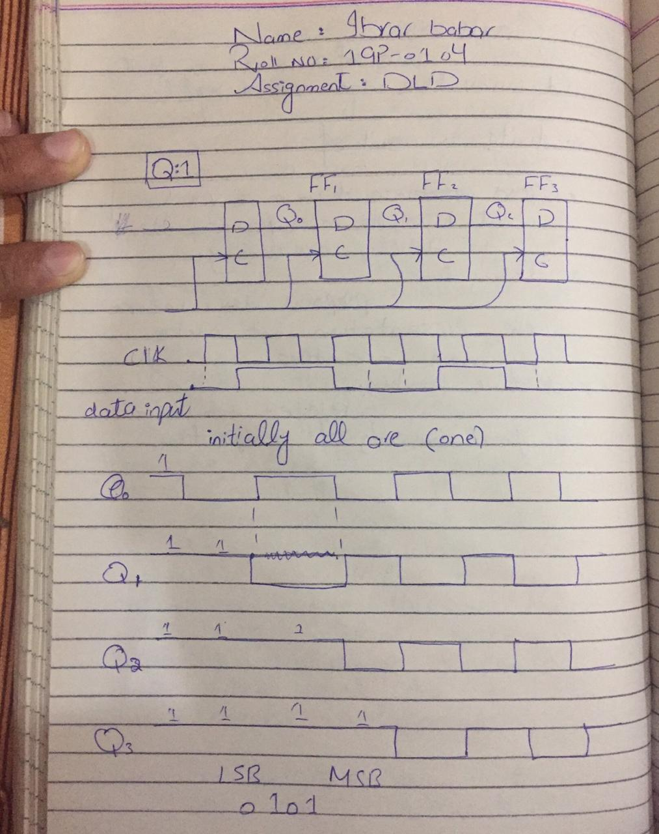

**Question 2;**

